**Lab 2: Setting Up the Database Context for a Retail Store**

1. Create Models:

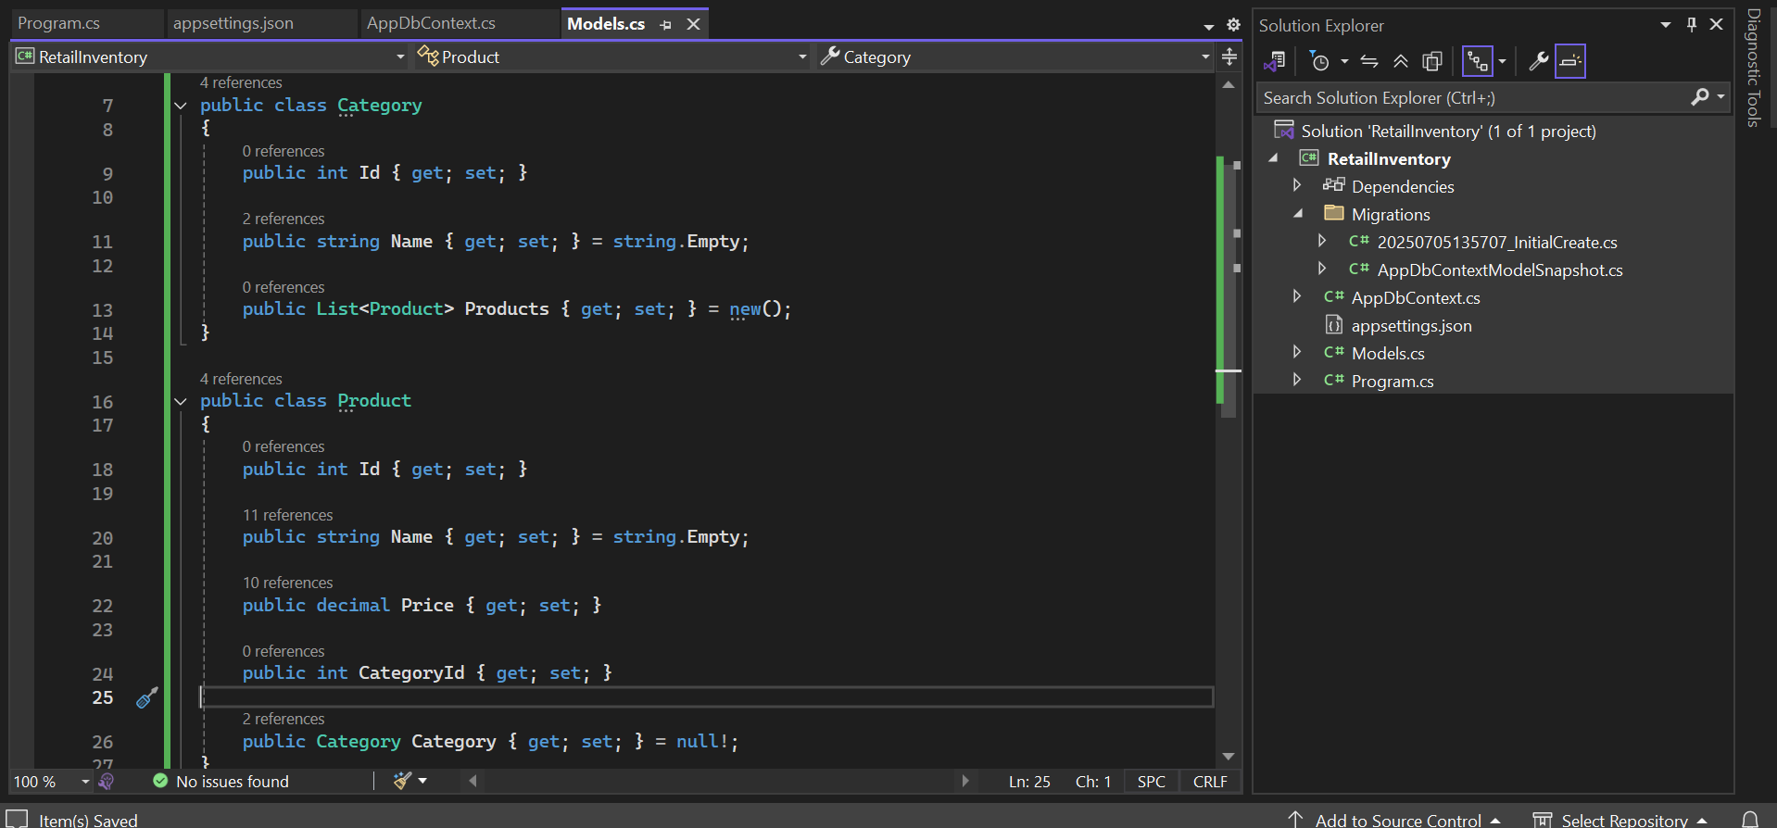

1. Create AppDbContext

